# Michael Chillemi

# 06/24/2023

# CS 590 - Algorithms

# M5.B3: Module 5 Hash Tables Application Exercises

Problem 6.7.19

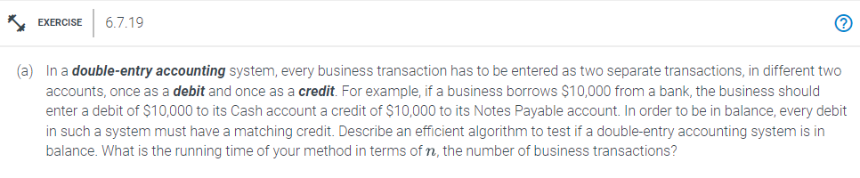

Answer:

Keeping track of the sums of all the debit and all the credit transactions would be an effective algorithm to determine whether a double-entry accounting system is in balance. The system is in balance if the two amounts are equal. This approach would take O(n) time to execute, where n is the total number of transactions. If a double-entry accounting system is provided to us with a list of all the business transactions that have occurred, we may determine whether the system is in balance by adding up all the debit transactions and comparing them to the sum of all the credit transactions. The system is in balance if the two amounts are equal. We can maintain track of a running total while we cycle over the list of transactions and efficiently add up all of the debit transactions. By setting a variable's initial value to 0, we can later add each debit transaction to the running total. The final total of all the debit transactions will be available once we have iterated through the whole list of transactions. Similar to the debit transactions, we can quickly add up all of the credit transactions by keeping track of a running total as we go through the list of transactions. Each credit transaction can be added to another variable. We'll know the total of all the credit transactions once we've gone through the complete list of transactions. We can easily compare the two values once we have the total of all debit transactions and total of all credit transactions. The system is in balance if they are equal. If they are not equal, the system is out of equilibrium. This approach would take O(n) time to execute, where n is the total number of transactions. This is due to the fact that in order to add up all of the credit and debit transactions, we must repeatedly go through the whole list of transactions.